Prompt (1.1):
You are a highly skilled requirements analyst tasked with extracting and organizing functional and non-functional requirements from the attached user story, which contains comprehensive details about the system to be developed. Your objective is to produce a clear, traceable, well-defined, and structured output in a standardized format suitable for software development stakeholders. Follow these instructions precisely:
- Input Analysis:
  - Carefully analyze the attached user story to identify all relevant details about the system.
  - Consider all sections of the user story, including but not limited to user roles, system features, interactions, constraints, and any implicit or explicit requirements.
- Requirements Extraction:
  - Functional Requirements: Identify and list all features, capabilities, and behaviors the system must perform. Each requirement should describe what the system does, including user interactions, system processes, inputs, outputs, and conditions.
  - Non-Functional Requirements: Identify and list all quality attributes, constraints, and performance criteria, such as usability, performance, scalability, security, reliability, maintainability, and compliance requirements.
  - Ensure no requirements are missed, even if they are implied or indirectly stated in the user story.
- Output Format:
  - Present the requirements in a structured, tabular format with the following columns:
    - ID: A unique identifier for each requirement (e.g., FR-001 for functional, NFR-001 for non-functional).
    - Type: Specify whether the requirement is Functional (FR) or Non-Functional (NFR).
    - Description: A clear, concise, and unambiguous description of the requirement.
    - Priority: Indicate the priority (e.g., High, Medium, Low) based on the user story context or inferred importance.
    - Source: Reference the specific section or part of the user story from which the requirement is derived (e.g., "User Story Section 2.1" or "User Role Description").
  - Group functional and non-functional requirements in separate tables for clarity.
  - Use numbered lists or bullet points within the description if a requirement has multiple sub-components.
- Quality Criteria:
  - Ensure each requirement is:
    - Clear: Written in simple, unambiguous language understandable by both technical and non-technical stakeholders.
    - Traceable: Linked to the specific part of the user story for easy reference and validation.
    - Well-Defined: Specific enough to be implemented and tested, avoiding vague terms like "fast" or "user-friendly" unless quantified.
    - Complete: Captures all relevant details from the user story without omitting critical aspects.
  - If assumptions are needed to clarify ambiguous or incomplete information, explicitly state them in a separate "Assumptions" section after the tables.
- Additional Instructions:
  - If the user story includes diagrams, workflows, or examples, incorporate relevant details into the requirements as needed.
  - If any part of the user story is unclear or contradictory, note these issues in a separate "Clarifications Needed" section and suggest questions to resolve them.
  - Do not invent requirements not supported by the user story unless explicitly stated as an assumption.
  - If the user story references external standards, regulations, or technologies, include these as part of the relevant requirements (e.g., compliance with GDPR for security).
- Deliverable:
  - Provide the output in the following structure:
    - Functional Requirements Table
    - Non-Functional Requirements Table
    - Assumptions (if any)
    - Clarifications Needed (if any)
  - Ensure the output is concise yet comprehensive, avoiding unnecessary repetition while covering all aspects of the system described in the user story.
- Constraints:
  - Do not modify or reinterpret the user story beyond what is necessary to extract requirements.
  - If the user story is missing or incomplete, clearly state this and provide a partial output based on available information, along with a note about the limitations.

Summary:
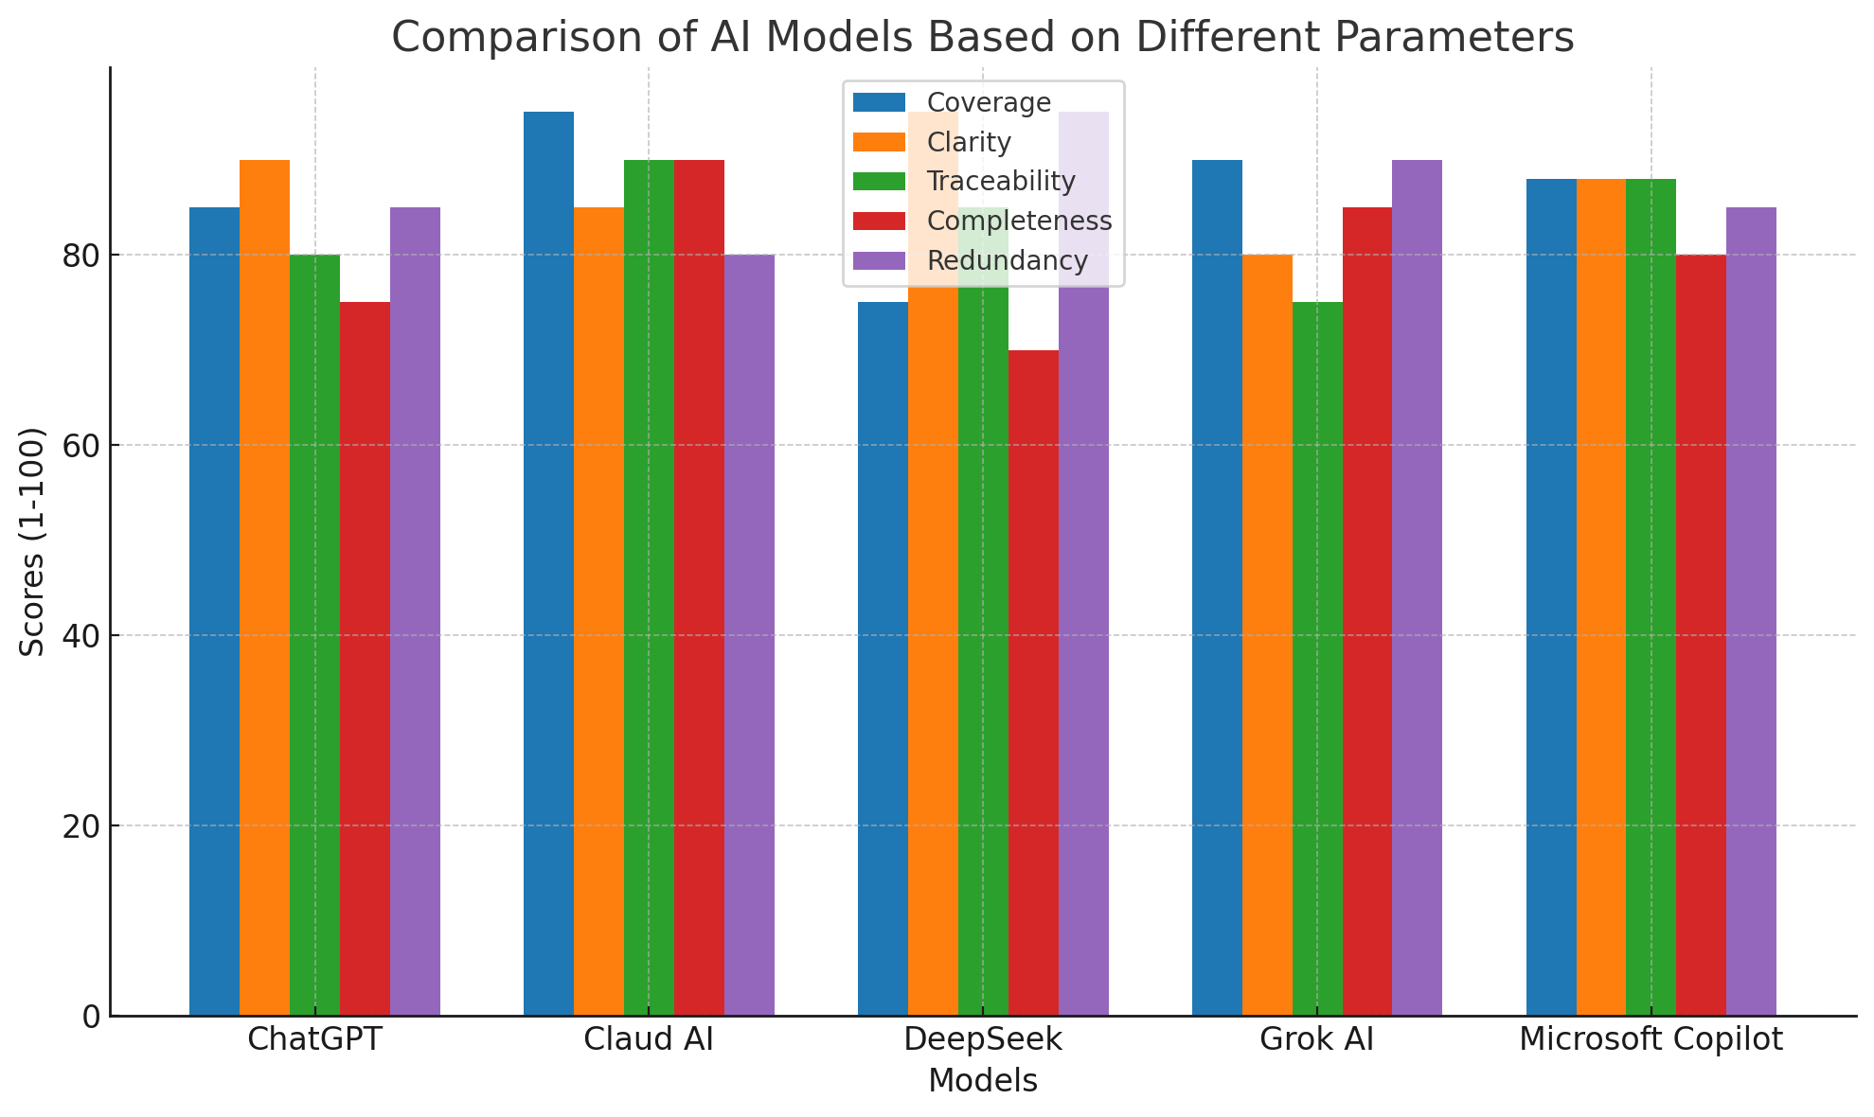
Comparative Analysis of AI Models for Requirement Extraction from SRS Document
Evaluation Criteria:
- Coverage (1-100): How comprehensively the model captures all functional/non-functional requirements.
- Clarity (1-100): Precision, conciseness, and readability of requirements.
- Traceability (1-100): Clear linkage between requirements and their sources in the SRS.
- Completeness (1-100): Inclusion of all necessary details (e.g., ER prioritization logic, inventory thresholds).
- Redundancy (1-100): Minimal duplication of requirements (higher = less redundancy).

Scores (1-100)
Model | Coverage | Clarity | Traceability | Completeness | Redundancy
ChatGPT | 85 | 90 | 80 | 75 | 85
Claud AI | 95 | 85 | 90 | 90 | 80
DeepSeek | 75 | 95 | 85 | 70 | 95
Grok AI | 90 | 80 | 75 | 85 | 90
Microsoft Copilot | 88 | 88 | 88 | 80 | 85

Key Insights
1. Coverage
- Claud AI (95) leads by breaking down complex features (e.g., lab workflows, staff management) into granular requirements.
- DeepSeek (75) lags due to over-consolidation (e.g., merging discharge/follow-up into one requirement).
- Others: Cover 85-90% of SRS content but omit nuances (e.g., ER tracking in Grok AI).
2. Clarity
- DeepSeek (95) uses concise, action-oriented language (e.g., "generate unique patient ID").
- Claud AI (85) loses points for verbosity (37 functional requirements).
- Copilot (88) balances brevity with specificity.
3. Traceability
- Claud AI (90) explicitly maps requirements to sections (e.g., "Appointment Booking Section").
- Grok AI (75) uses vague sources (e.g., "PAGE 1 - Doctor Features").
- Copilot (88) uses clear section labels (e.g., "Emergency Care Section").
4. Completeness
- Claud AI (90) addresses ambiguities (e.g., adds ER tracking, inventory auto-updates).
- DeepSeek (70) misses critical details (e.g., no ER prioritization logic).
- ChatGPT (75) omits specifics (e.g., "industry standards" undefined).
5. Redundancy
- DeepSeek (95) avoids duplication by consolidating related features.
- Claud AI (80) has minor overlaps (e.g., separate requirements for lab requests/results).
- Others: Manageable duplication (e.g., billing/payment repeated in Grok AI).

Recommendations
- For Detail-Oriented Projects: Use Claud AI for exhaustive coverage (e.g., regulatory compliance).
- For Concise Documentation: Prefer DeepSeek or Copilot for streamlined requirements.
- Avoid: Grok AI for traceability-critical projects; ChatGPT for ambiguous contexts.

